**Project proposal**

LTE Network Shakedown App

**Title**

Android app for gathering mobile network details

**Background**

Despite the existence of some similar mobile apps, they force the installation of a firmware in the device in order to access low-level functions that allow measure of the mobile network details. In light to this, CYCLOID, a company in the mobile and communications market, felt the need for a free, easy to port app, that would convert Android devices into network analyzers with as little modifications has possible with each next device model.

The main goal is to create an application that would allow users to scan the network and acquire detailed information. This application should require very minimal changes in order to function in another device model.

**Objectives**

* Identify required details from mobile network, separating which can be acquired with Android API and which need native API
* Design an App that will acquire and save all required details from the mobile network
* Create UI that allow the user to analyze the gathered information
* Craft a Native C library to access low level functions
* Keep each device specifics separated and has minimal has possible
* Allow data to be exported to an online database

**Justification**

The Project will allow me to consolidate my Android knowledge. It will also give me experience in Apps creation and deploying, which are increasingly mandatory, work in Android native C which is a rare and valuable experience. While working next CYCLOID I’ll certainly gain valuable knowledge and insight, useful for creating a business-ready product. This is also a good opportunity to assert that I can maintain a schedule and enforce milestones.

**Scope**

The functional scope of the Project and isn’t limited to CYCLOID. It’s meant to be free and available at android App Store for whomever wants’ to use it:

* Has a measure tool for scanning and gathering network data
* For educational purposes, allowing students to have a free, easy to port application to measure data

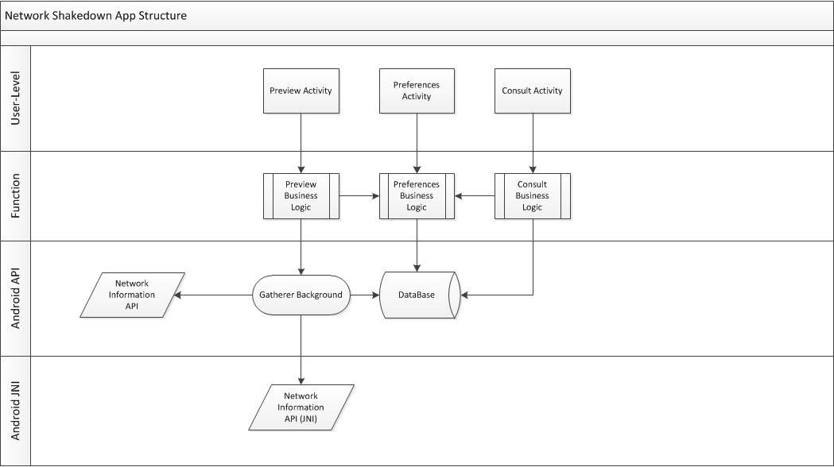

**Design**

**Major milestones**

Detailed plans will be produced as part of the Project Initiation Document, but the following milestones are mandatory:

* **Project proposal** -> 17 March 2014
* **Progress report and individual presentation** -> 5 May 2014
* **Cardboard and beta version** -> 16 June 2014
* **Final version** -> 26 July 2014

**Planning & Schedule**

After considering the major milestones and some initial planning we established some deadlines, however since we haven’t heard CYCLOID initial briefing these milestones might change after our meeting.

* **Project proposal** -> 17 March 2014
* CYCLOID meeting and brainstorm(*) -> 31 March 2014
* Research of native functions -> 7 April 2014
* Working prototype with limited functionality -> 21 April 2014
* Almost-fully working prototype -> 28 April 2014
* 1st Phase Review -> 5 May 2014
* **Progress report and individual presentation** -> 5 May 2014
* 1st Feedback and tuning -> 19 May 2014
* Fully functioning prototype -> 26 May 2014
* Final changes and 2nd Phase Review-> 16 June 2014
* **Cardboard and beta version** -> 16 June 2014
* 2nd Feedback and tuning -> 30 June 2014
* Reports compiling Android Market deployment -> 26 July 2014
* **Final version** -> 26 July 2014

**Constraints and assumptions**

In order to confirm the measures are correct I will require another device (not using my application) to perform the scanning of the mobile networks. Also it would be best if I could test the App with other devices than my own to have a sense of how much effort is made into allowing other devices to run the App. Additional details of network information may be suggested by CYCLOID with each meeting, therefore the application must allow these accommodations with relative ease.

**Resources**

The Project is expected to make use of open-source software. The hardware (devices) to be used is my own or, if possible, supplied by CYCLOID.

**Risks**

The main risk is the native C API. Due to some functions require access to a more low level API it is uncertain how many details can be extracted from the mobile network and which devices allow access to those details.

**Project organization**

* The Project will be conducted by me
* The Project supervisor will be Engº Pedro Pereira and Engº Nuno Cota
* The partner CYCLOID will contribute with insight and requirements